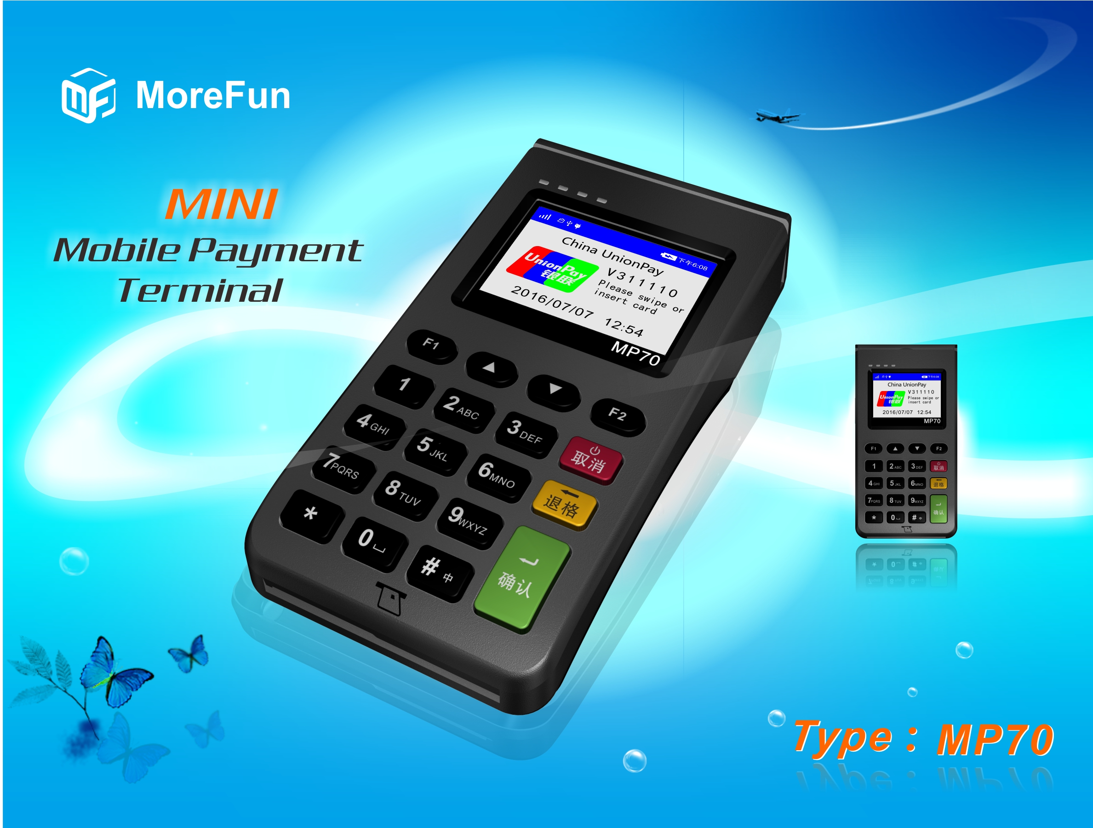

Product description:
MP70 is a mini mobile payment terminal developed by Fujian MoreFun Electronic Technology Co., which can directly dock with payment platform through wireless GPRS/WIFI, deliver transaction by handwriten signature on screen, quickly finish payment. It is innovative simple mobile payment terminal. With payment function for magnetic stripe card, contact chip card and contactless chip card, support scanning code payment for screen displayed two-dimensional code, optional support barcode payment for built-in 1D/2D scanner, it can meet the diversified demands of future payment modes.

Product features:
- Compact design, thin & portable, cost-effective
- 320*240 color LCD, support handwriting signature on screen
- Diversified payment types, with bank card’s (magnetic stripe card, contact and contactless chip card) receipts collecting and payment function, support merchant and client O2O scanning code payment function.
- Intelligent power-saving technology, enhanced battery life, support more transactions.

Product specification:
Processor | - High performance 32-bit security CPU
Memory | - 1MB Flash ,128KB SRAM  - External 64MB large capacity memory
Display screen | - 320*240 lattice LCD, with backlight  - Touch screen, support handwriten signature
Keyboard | - 0~9 number key, function, confirm, cancel, delete, on/off, 15 keys in total, key tone available
Magnetic card reader | - Support 2/3 magnetic tracks bi-diractional card reading  - Support high coercivity magnetic card reading  - Can support ISO 7810、ISO7811-1,2,3,4,5,6、ISO7813 standard magnetic stripe card reading  - Can support 0.1m/s～1m/s swiping card speed
IC card reader | - One user card base  - Support 3V or 5V card  - Support ISO7816CPU card, conform to PBOC and EMV standard
Contactless card reader (optional) | - 13.56MHZ, support ISO14443 Type A/B, Mifare one card
Barcode reader (optional) | - Built-in 1D/2D barcode reader
Password keyboard | - Built-in password keyboard  - Conform to ANSI X9.8/ISO9564, ANSI X9.9/ISO8731 standard  - Support DES, 3DES, RSA, SHA-256 algorithm  - Support MK/SK
Communication | - WIFI/GPRS/ WIFI+dual mode bluetooth/ GPRS+dual mode bluetooth (four choose one)，bluetooth communication can support external bluetooth printer
Battery | - Built-in rechargeable lithium battery: 3.7V 800mAH
Charge Port | - Standard Micro USB interface charge
Size | - 135.0 mm X 71.1 mm X 30.8mm
Certification | - EMV/PBOC 3.0 Level1&Level2 certificate  - PBOC 3.0 non-contact Level1&Level2 certificate  - MPOS terminal device PIN security certificate
Product outside view:

Product size: 135.0 mm X 71.1 mm X 30.8mm
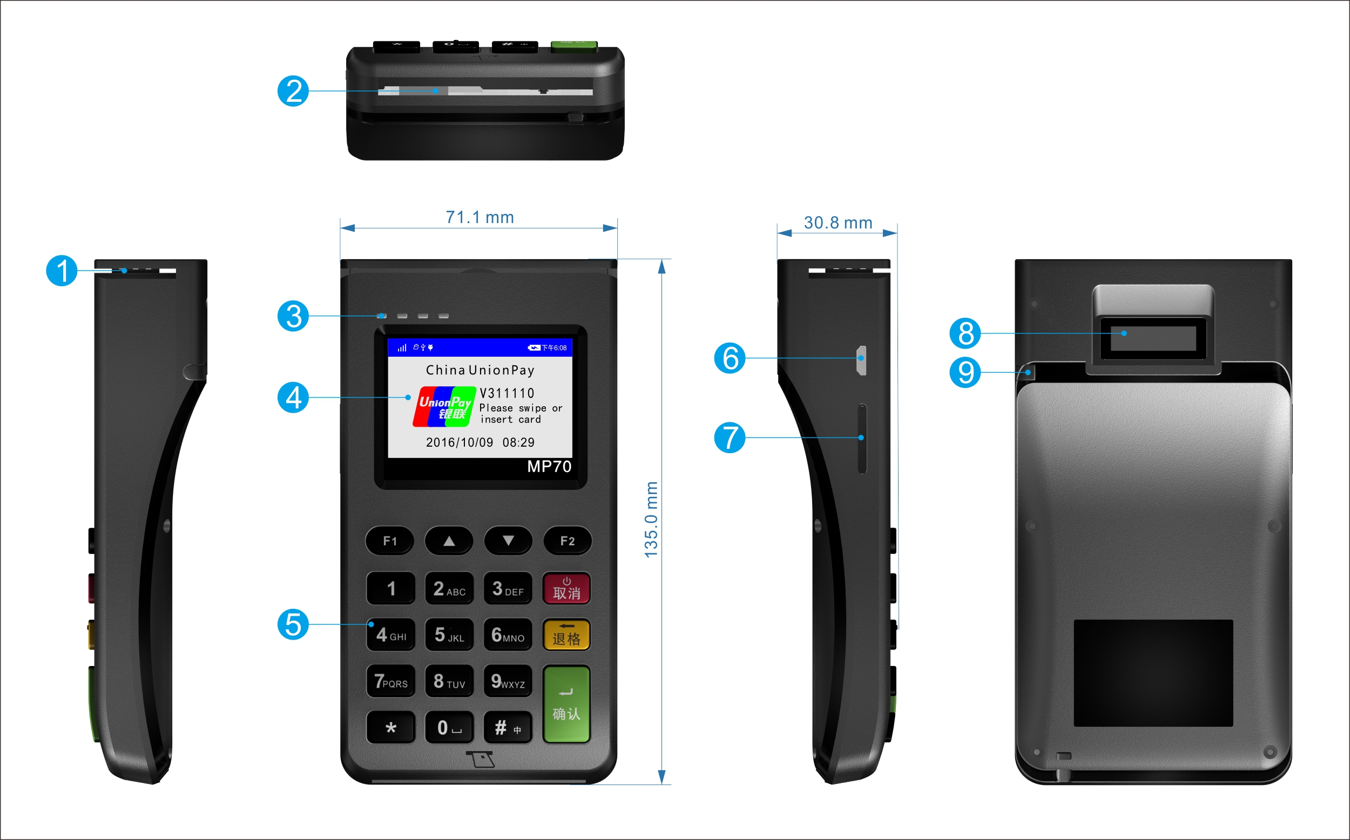
① Magnetic card slot
② IC card slot
③ Non-connected light
④ LCD display screen
⑤ Password keyboard
⑥ USB charge interface
⑦ SIM card slot
⑧ 1D/2D scanning code window
⑨ Handwriting pen socket

Brand promotion option:
In order to help customer to promote their brand successfully, we can mark customer logo on product’s front or back side as customer requirement, so to improve the effect of brand promotion.

Product application scene:
Through wireless communication way such as GPRS and WI-FI to dock with payment platform, quickly finish payment function, it can be widely used in various industries.
- Small merchant receipts collecting
- Insurrance issuing upon expense appearred
- Logistics pay on delivery
- Mobile individual payment
- Supermarket cashier system
- O2O scanning payment

